Orchid Grove
Community Development District
Agenda
Thursday

Seat 1: Gerald Stanton - C.

Seat 4: Carol Str ker - A.S.
Seat 2: Sheree Davie - A.S.
Orchid Grove Clubhouse
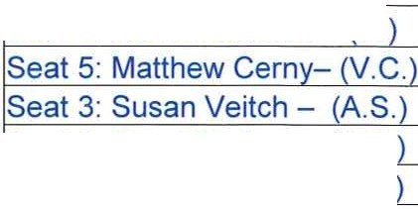

March 10, 2022
4:00 p.m.
651 S.W. 1st Ave., Pompano Beach, Florida https://meet.goto.com/397896613
+1 (872) 240-3212; Access Code: 397-896-613

- Roll Call

- Approval of the Minutes of the February 10, 2022 Meeting

- Staff Reports
  - Attorney

  - Engineer - Discussion/Updates on Stormwater Management Needs Analysis

  - Clubhouse

  - Field Manager

  - COD Manager

- Financial Reports
  - Approval of Check Run Summary

8. Balance Sheet and Income Statement

- Supervisors Requests and Audience Comments

- Adjournment

Meetings are open to the public and may be continued to a time, date and place certain. For more information regarding this CDD please visit the website: http://www.orchidgrovecdd.com

